**COURSE OUTCOME 3**

**PROGRAM NO: 1**

**AIM:**

To find area of different shapes using overloaded functions.

**ALGORITHM:**

Step 1: Start

Step 2: Define the main class

Step 3: Define methods with the same methodname that performs the area operation for each shape

Step 4: Display the areas of each shapes.

**PROGRAM CODE:**

|  |  |
| --- | --- |
| CO3Q1.java | **import java.util.Scanner;**  **public class CO3Q1**  **{**  **double area(float r)**  **{**  **double pi = 3.14;**  **double ar;**  **ar = pi*r*r;**  **return ar;**  **}**  **double area(float h,float b)**  **{**  **double ar;**  **ar = (h*b)/2;**  **return ar;**  **}**  **double area(double s)**  **{**  **double ar;**  **ar = s*s;**  **return ar;**  **}**  **double area(double l,double br)**  **{**  **double ar;**  **ar = l*br;**  **return ar;**  **}**  **public static void main(String[] args)**  **{**  **CO3Q1 obj = new CO3Q1();**  **int ch;**  **float r,h,b;**  **double s,l,br;**  **System.out.println("Enter the option:");**  **System.out.println("1. Area of the circle");**  **System.out.println("2. Area of the triangle");**  **System.out.println("3. Area of the square");**  **System.out.println("4. Area of the rectangle");**  **Scanner sc = new Scanner(System.in);**  **System.out.println("Enter the choice");**  **ch = sc.nextInt();**  **switch(ch)**  **{**  **case 1: System.out.println("Enter the radius:");**  **r = sc.nextFloat();**  **System.out.println(obj.area(r));**  **break;**  **case 2: System.out.println("Enter the height and breadth:");**  **h = sc.nextFloat();**  **b = sc.nextFloat();**  **System.out.println(obj.area(h,b));**  **break;**  **case 3: System.out.println("Enter the length of the side:");**  **s = sc.nextDouble();**  **System.out.println(obj.area(s));**  **break;**  **case 4: System.out.println("Enter the length and breadth:");**  **l = sc.nextDouble();**  **br = sc.nextDouble();**  **System.out.println(obj.area(l,br));**  **break;**  **default: System.out.println("Invalid choice.");**  **}**  **}**  **}** |

**OUTPUT:**

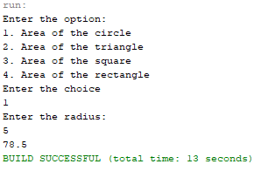 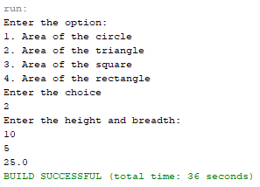

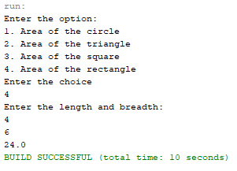 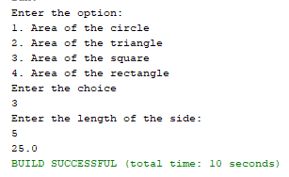

**RESULT:**

The program is successfully executed and the output is verified.

**PROGRAM NO: 2**

**AIM:**

To create a class ‘Employee’ with data members Empid, Name, Salary, Address and constructors to initialize the data members. Create another class ‘Teacher’ that inherit the properties of class employee and contain its own data members department, Subjects taught and constructors to initialize these data members and also include display function to display all the data members. Use array of objects to display details of N teachers.

**ALGORITHM:**

**Step.1**: Start the program.

**Step.2**: Define a class ‘*Employee*’ with data members Empid, Name, Salary, Address and a constructor to initialize these members.

**Step.3**: Define a class ‘*Teacher*’ that inherit the properties of class ‘Employee’ and contain its own data members Department, Subjects taught and constructors to initialize these data members and also include a method Display() to display all the data members.

**Step.4**: Define a main() to create array of objects for the class to display the details of ‘N’ teachers.

**Step.5**: Stop the program.

**PROGRAM CODE:**

|  |  |
| --- | --- |
| employee.java | class Employee2  {  int Empid;  String Name;  float Salary;  String Address;    Employee2()  {    }  public Employee2(int id, String name, float sal, String addr)  {  Empid = id;  Name = name;  Salary = sal;  Address = addr;  }    }  class Teacher extends Employee2  {  String department;  String Subjects;  public Teacher(int id, String name, float sal, String addr, String dept, String sub)  {  super(id, name, sal, addr);  department = dept;  Subjects = sub;    }  Teacher()  {    }  public void display()  {  System.out.println("Employee ID - "+Empid);  System.out.println("Employee Name - "+Name);  System.out.println("Salary - "+Salary);  System.out.println("Address - "+Address);  System.out.println("Department - "+department);  System.out.println("Subject - "+Subjects);  }    }  public class CO3Q2  {  public static void main(String[] args)  {  int n;  Scanner sc = new Scanner(System.in);  System.out.println("Enter the number of Teachers to be added:");  n = sc.nextInt();  Teacher obj[] = new Teacher[n];  for (int i=0; i<n; i++)  {  obj[i] = new Teacher();  }  for(int i=0;i<n;i++)  {  System.out.println("\t*****");  System.out.println("Enter Employee ID");  obj[i].Empid = sc.nextInt();  sc.nextLine();  System.out.println("Enter Employee Name");  obj[i].Name = sc.nextLine();  System.out.println("Enter Employee Salary");  obj[i].Salary = sc.nextFloat();  sc.nextLine();  System.out.println("Enter Employee Address");  obj[i].Address = sc.nextLine();  System.out.println("Enter Employee Department");  obj[i].department = sc.nextLine();  System.out.println("Enter Employee Subject");  obj[i].Subjects = sc.nextLine();  }  System.out.println("\t***************");  System.out.println("Employee Details:-");  for(int i=0;i<n;i++)  obj[i].display();  }  } |

**OUTPUT:**

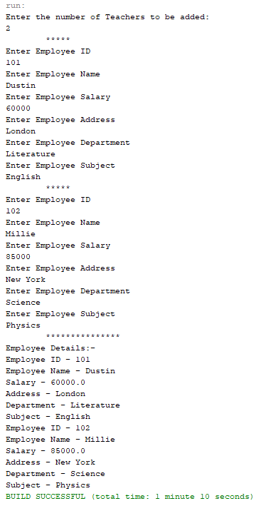

**RESULT:**

The program is successfully executed and the output is verified.

**PROGRAM NO: 3**

**AIM:**

To create a class ‘Person’ with data members Name, Gender, Address, Age and a constructor to initialize the data members and another class ‘Employee’ that inherits the properties of class Person and also contains its own data members like Empid, Company_name,

Qualification, Salary and its own constructor. Create another class ‘Teacher’ that inherits the properties of class Employee and contains its own data members like Subject, Department, Teacherid and also contain constructors and methods to display the data members. Use array of objects to display details of N teachers.

**ALGORITHM:**

Step 1: Start

Step 2: Create a class named ‘*Person’* with data members name, gender, address and age

& a constructor to initialize them.

Step 3: Create a class named ‘*Employee’* which is derived from Person, with data members

empid, cmpnyname, qualification and sal & a constructor Employee() to initialize them.

Step 4: Create class named ‘Teach” which is derived from Employee, with data members

subject, dept and tid ; a constructor to initilize members ; and a function named

display() to display details.

Step 5: Create an array of objects to display details.

Step 6: Stop

**PROGRAM CODE:**

|  |  |
| --- | --- |
| CO3Q3.java | **import java.util.Scanner;**  **class Person**  **{**  **String Name;**  **String Gender;**  **String Address;**  **int Age;**  **Person()**  **{**    **}**  **Person(String name, String gender, String addr, int age)**  **{**  **Name = name;**  **Gender = gender;**  **Address = addr;**  **Age = age;**  **}**  **}**  **class Employee extends Person**  **{**  **int Empid;**  **String Company_name;**  **String Qualification;**  **float Salary;**  **Employee()**  **{**    **}**  **public Employee(String name, String gender, String addr, int age)**  **{**  **super(name, gender, addr, age);**  **}**  **public Employee(int id,String name, String qual, float sal)**  **{**  **Empid = id;**  **Company_name = name;**  **Qualification = qual;**  **Salary = sal;**  **}**    **}**  **class Teacher extends Employee**  **{**  **String Subject;**  **String Department;**  **String Teachersid;**  **Teacher()**  **{**    **}**  **Teacher(String sub, String dept, String id)**  **{**  **Subject = sub;**  **Department = dept;**  **Teachersid = id;**  **}**  **public void display()**  **{**  **System.out.println("Name:" + Name);**  **System.out.println("Age:" + Age);**  **System.out.println("Gender:" + Gender);**  **System.out.println("Address:" + Address);**  **System.out.println("Emp id:" + Empid);**  **System.out.println("Salary:" + Salary);**  **System.out.println("Qualification:" + Qualification);**  **System.out.println("Company Name:" + Company_name);**  **System.out.println("Teacher id:" + Teachersid);**  **System.out.println("Subject:" + Subject);**  **System.out.println("Department:" + Department);**  **System.out.println("\n\n");**  **}**  **}**  **public class CO3Q3**  **{**  **public static void main(String[] args)**  **{**  **int n;**  **System.out.println("Enter the no. of Teachers:");**  **Scanner sc = new Scanner(System.in);**  **n = sc.nextInt();**  **Teacher obj[] = new Teacher[n];**  **for(int i=0;i<n;i++)**  **obj[i] = new Teacher();**  **sc.nextLine();**  **for(int i=0;i<n;i++)**  **{**  **System.out.println("\t*****");**  **System.out.println("Enter the name:");**  **obj[i].Name = sc.nextLine();**    **System.out.println("Enter the Age:");**  **obj[i].Age = sc.nextInt();**  **sc.nextLine();**  **System.out.println("Enter the Gender:");**  **obj[i].Gender = sc.nextLine();**  **System.out.println("Enter the Address:");**  **obj[i].Address = sc.nextLine();**  **System.out.println("Enter the Emp id:");**  **obj[i].Empid = sc.nextInt();**  **System.out.println("Enter the Salary:");**  **obj[i].Salary = sc.nextFloat();**  **sc.nextLine();**  **System.out.println("Enter the Qualification:");**  **obj[i].Qualification = sc.nextLine();**  **System.out.println("Enter the Company Name:");**  **obj[i].Company_name = sc.nextLine();**  **System.out.println("Enter the Teacher id:");**  **obj[i].Teachersid = sc.nextLine();**  **System.out.println("Enter the Subject:");**  **obj[i].Subject = sc.nextLine();**  **System.out.println("Enter the Department:");**  **obj[i].Department = sc.nextLine();**  **}**  **System.out.println("\t***************");**  **System.out.println("Teachers Details:-\n");**  **for(int i=0;i<n;i++)**  **obj[i].display();**  **}**    **}** |

**OUTPUT:**

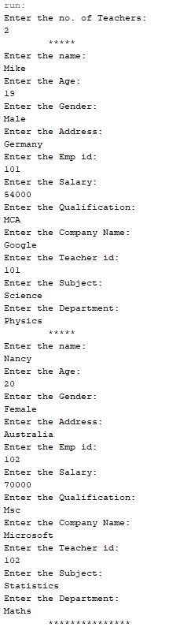 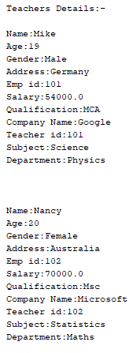

**RESULT:**

The program is successfully executed and the output is verified.

**PROGRAM NO: 4**

**AIM:**

To write a program has class Publisher, Book, Literature and Fiction. Read the information and print the details of books from either the category, using inheritance.

**ALGORITHM:**

Step 1: Start

Step 2:Create a class named ‘Publisher’ with data members pname, pid; a constructor named

Publisher().

Step 3: Create a class named ‘Book’ which is derived ‘Publisher’ with data members nop, price; a constructor named Book().

Step 4: Create a class named ‘literature’ which is derived from Book with data members title, author; a constructor; a function show() to display details.

Step 5: Create a class named ‘fiction’ which is derived from Book with data members bname, auth; a constructor; a function display() to print details.

Step 6: Print a menu defining the type of genres; if literature create an object of literature

type and object of type fiction if fiction is chosen.

Step 7 : Stop

**PROGRAM CODE:**

|  |  |
| --- | --- |
| CO3Q4.java | **import java.util.Scanner;**  **public class CO3Q4**  **{**  **public class publisher**  **{**  **String pub_name;**  **publisher(){}**  **publisher(String name)**  **{**  **pub_name = name;**  **}**  **}**  **static public class Book extends publisher**  **{**  **String book_name;**  **Book(){}**  **Book(String bname, String pname)**  **{**  **super(pname);**  **book_name = bname;**  **}**  **public void display()**  **{**  **System.out.println("\n\n**********\n\nBook Details");**  **System.out.println("Publisher:"+ pub_name);**  **System.out.println("Book:"+book_name);**  **}**  **}**  **static public class literature extends Book**  **{**  **String book_genre;**  **public literature() {}**  **literature(String name,String book,String genre)**  **{**  **super(name,book);**  **book_genre = genre;**  **super.display();**  **System.out.println("Genre:"+book_genre);**  **}**    **}**  **static public class fiction extends Book**  **{**  **String book_genre;**  **fiction(){}**  **fiction(String name,String book,String genre)**  **{**  **super(name,book);**  **book_genre = genre;**  **super.display();**  **System.out.println("Genre:"+book_genre);**  **}**  **}**      **public static void main(String[] args)**  **{**  **String name,book,genre;**    **Scanner sc = new Scanner(System.in);**  **System.out.println("Enter the book details...");**  **System.out.println("Enter the Book name:");**  **book = sc.nextLine();**  **System.out.println("Enter the Publisher name:");**  **name = sc.nextLine();**  **System.out.println("Enter the Genre name:");**  **genre = sc.nextLine();**  **fiction obj;**  **literature ob;**  **if(genre.toLowerCase().equals("fiction"))**  **{**  **obj = new fiction(name,book,genre);**  **}**  **else if(genre.toLowerCase().equals("literature"))**  **ob = new literature(name,book,genre);**  **else**  **System.out.println("Enter Fiction or Literature");**  **}**  **}** |

**OUTPUT:**

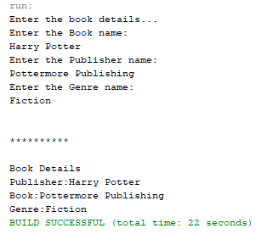

**RESULT:**

The program is successfully executed and the output is verified.

**PROGRAM NO: 5**

**AIM:**

To create classes Student and Sports. Create another class Result inherited from Student and Sports. Display the academic and sports score of a student.

**ALGORITHM:**

**Step.1**: Start the program.

**Step.2**: Define a class ‘*Student*’ which will read a student’s academic information from the user.

**Step.3**: Define another class ‘*Sports*’ that extends ‘*Student*’ and reads the sports data of the student.

**Step.4**: Define another interface ‘R*esults*’ that extends ‘*Sports*’and has a *Display()* to display the profile, academic score and sports score of the student.

**Step.5**: Define a main () method to create objects for the above classes and to call the associated member methods.

**Step.6**: Stop the program.

**PROGRAM CODE:**

|  |  |
| --- | --- |
| CO3Q5.java | import java.util.Scanner;  interface results  {  void getdata();  int display();  }  class Student implements results  {  int std_id,std_tmark;  String std_name;  @Override  public void getdata()  {  Scanner sc = new Scanner(System.in);  System.out.println("Enter the name of the student:");  std_name = sc.nextLine();  System.out.println("Enter the student id:");  std_id = sc.nextInt();  System.out.println("Enter total academic mark:");  std_tmark = sc.nextInt();  }  @Override  public int display()  {  System.out.println("\t--------Student details--------");  System.out.println("Student name: " +std_name);  System.out.println("Student id: " +std_id);  System.out.println("Total mark:" +std_tmark);  return std_tmark;  }  }  class Sports implements results  {  int tmarks;  @Override  public void getdata()  {  Scanner sc = new Scanner(System.in);  System.out.println("Enter the marks obtained in sports:");  tmarks = sc.nextInt();  }  @Override  public int display()  {  System.out.println("Marks obtained in Sports:"+ tmarks);  return tmarks;  }    }  public class CO3Q5  {  public static void main(String[] args)  {  int mark;  Student ob = new Student();  Sports obj = new Sports();  ob.getdata();  obj.getdata();  mark = ob.display();  mark = mark + obj.display();  System.out.println("Marks(Academic+Sports)="+ mark);  }  } |

**OUTPUT:**

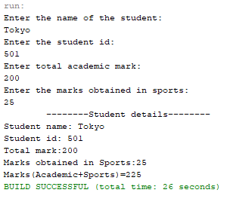

**RESULT:**

The program is successfully executed and the output is verified.

**PROGRAM NO: 6**

**AIM:**

To create an interface having prototypes of functions area() and perimeter(). Create two classes Circle and Rectangle which implements the above interface. Create a menu driven program to find area and perimeter of objects.

**ALGORITHM:**

**Step.1**: Start the program.

**Step.2**: Define an interface ‘*prop*’ with methods to read inputs and calculate area and perimeter.

**Step.3**: Define a class ‘*Rectangle*’ that extends *Circle* to initialize its data members l, b and to calculate and display the area and perimeter of a rectangle.

**Step.4**: Define a main () to create objects for the above classes to invoke its member methods to print the results.

**Step.5**: Stop the program.

**PROGRAM CODE:**

|  |  |
| --- | --- |
| CO3Q6.java | import java.util.Scanner;  interface prop{  void getdata();  void area();  void perimeter();  }  class Circle implements prop{  double pi = 3.14;  double r;  Scanner sc = new Scanner(System.in);  @Override  public void getdata(){  System.out.println("Enter the radius of the circle:");  r = sc.nextDouble();  }  @Override  public void perimeter(){  System.out.println("Perimeter of the circle: "+(2*pi*r));  }  @Override  public void area(){  System.out.println("Perimeter of the circle: "+(pi*r*r));  }  }  class Rectangle implements prop{  double l,b;  Scanner sc = new Scanner(System.in);  @Override  public void getdata(){  System.out.println("Enter the length of the rectangle:");  l = sc.nextDouble();  System.out.println("Enter the breadth of the rectangle:");  b = sc.nextDouble();  }  @Override  public void area(){  System.out.println("Perimeter of a rectangle: "+(l*b));  }  @Override  public void perimeter(){  System.out.println("Perimeter of a rectangle: "+(2*(l+b)));  }  }  public class CO3Q6 {  public static void main(String[] args) {  int ch;  Scanner sc = new Scanner(System.in);  Circle ob = new Circle();  Rectangle obj = new Rectangle();  do{  System.out.println("\n1.Circle\n2.Rectangle\n3.exit");  System.out.println("Enter your choice:");  ch = sc.nextInt();  switch(ch){  case 1 :ob.getdata();  ob.area();  ob.perimeter();  break;  case 2 :obj.getdata();  obj.area();  obj.perimeter();  break;  case 3 :System.out.println("Exited...");  System.exit(0);  }  }while(true);  }  } |

**OUTPUT:**

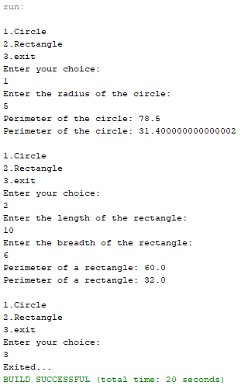

**RESULT:**

The program is successfully executed and the output is verified.

**PROGRAM NO: 7**

**AIM:**

To prepare bill with the given format using calculate method from interface.

Order No.

Date:

Product Id Name Quantity unit price Total

101 A 2 25 50

102 B 1 100 100

Net. Amount 150

**ALGORITHM:**

**Step.1**: Start the program.

**Step.2**: Define an interface *calc* with a method calculate().

**Step.3**: Define a class *bill* that implements *calc* to calculate the total amount for each product and has methods to generate a bill as given in the question.

**Step.4**: Define a main () to create objects for the class.

**Step.5**: Invoke the above methods by passing the data collected from user to generate the required bill.

**Step.6**: Stop the program.

**PROGRAM CODE:**

|  |  |
| --- | --- |
| CO3Q7.java | import java.util.Scanner;  interface calc{  void calculate();  }  class bill implements calc{  String date,name,p_id;  int quantity;  double unit_price,total,namount=0;  Scanner sc = new Scanner(System.in);  public void getdata(){  System.out.println("\nEnter product id:");  p_id = sc.nextLine();  System.out.println("Enter product name:");  name = sc.nextLine();  System.out.println("Enter the Quantity:");  quantity = sc.nextInt();  System.out.println("Enter the unit price:");  unit_price = sc.nextDouble();  }  @Override  public void calculate(){  total = quantity * unit_price;  }  public void display(){  System.out.println(p_id+"\t\t"+name+"\t\t"+quantity+"\t\t"+unit_price+"\t"+total);  }  }  public class CO3Q7 {  public static void main(String[] args) {  int n,i;  double namount=0,t;  int ran;  String date;  t = Math.random() *1000000;  ran = (int) t;  Scanner sc = new Scanner(System.in);  System.out.println("Order no. #"+ran);  System.out.println("Enter the date:");  date = sc.nextLine();  System.out.println("Enter how many products are there:");  n = sc.nextInt();  bill ob[] = new bill[n];  for(i=0;i<n;i++)  ob[i] = new bill();  for(i=0;i<n;i++){  ob[i].getdata();  ob[i].calculate();  }  System.out.println("Date:"+date);  System.out.println("Product Id \tName\t Quantity\t unit price\t Total ");  System.out.println("--------------------------------------------------------------");  for(i=0;i<n;i++){  ob[i].display();  namount += ob[i].total;  }  System.out.println("--------------------------------------------------------------");  System.out.println("\t\t\tNet.Amount\t"+ namount);  }} |

**OUTPUT:**

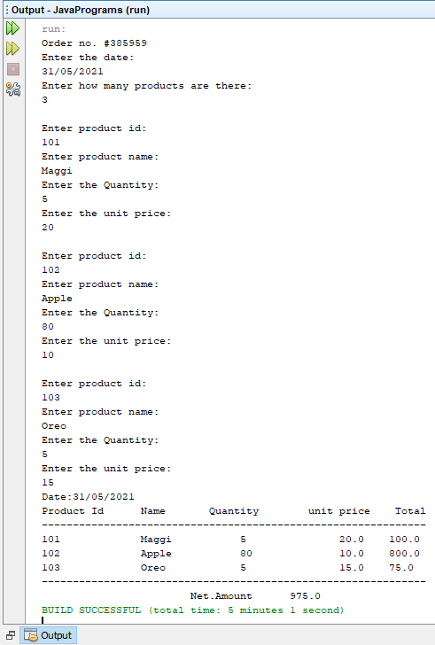

**RESULT:**

The program is successfully executed and the output is verified.